



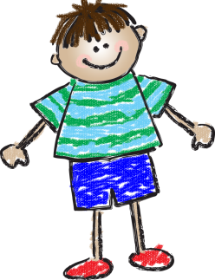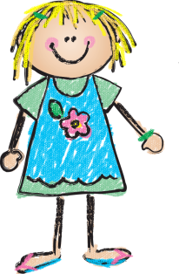

**with Ms. Rance**

**April 12, 2013**



**Weekly News…**



Please visit our class website: missrancekindergarten.weebly.com to see all the fun we had at the zoo! This was a wonderful learning experience for the students!

The kindergartners are gaining so much experience with the iPads. They have recently started their own journals using an iPad app that allows them to add photos, text, drawings and stamps and stickers to enhance their writing. I have never seen them so excited about journaling! It is so fun to watch them grow as individual learners with technology integration.

Have a great weekend!

Ms. Rance

**Quote of the Week:**

“The important thing is not to stop questioning.“ 

-Albert Einstein

**Reminders**

Keep practicing sight words at home! The students are getting very good at reading. The best thing you can do to assist in this learning process is to read daily with them at home. I encourage you to look in our school library for new, fun books!

**A Look at Next Week…**

**We have learned a lot about Earth day and ways that we can help take care of the earth. We will continue this study through an “animal rescue” play center, a nature hike, daily recycling routines and a science and social studies unit on plants.**

**Sight Words**

**out**

**great**

**make**

**play**

**Dates to Remember  
April 26th:** Crazy Hair/Hat Day!

**May 16th:** Beach Day

**May 17th:** NO SCHOOL