





**with Ms. Rance**

**February 15, 2013**



**Weekly News…**



**Reminders**

Keep practicing sight words at home! The students are getting very good at reading. The best thing you can do to assist in this learning process is to read daily with them at home. I encourage you to look in our school library for new, fun books!

**A Look at Next Week…**

**We are working on time in math. The students are almost finished with their digital stories! When they are completed I will send you a link to their story so they can share it with you at home! I am so proud of all their hard work!**

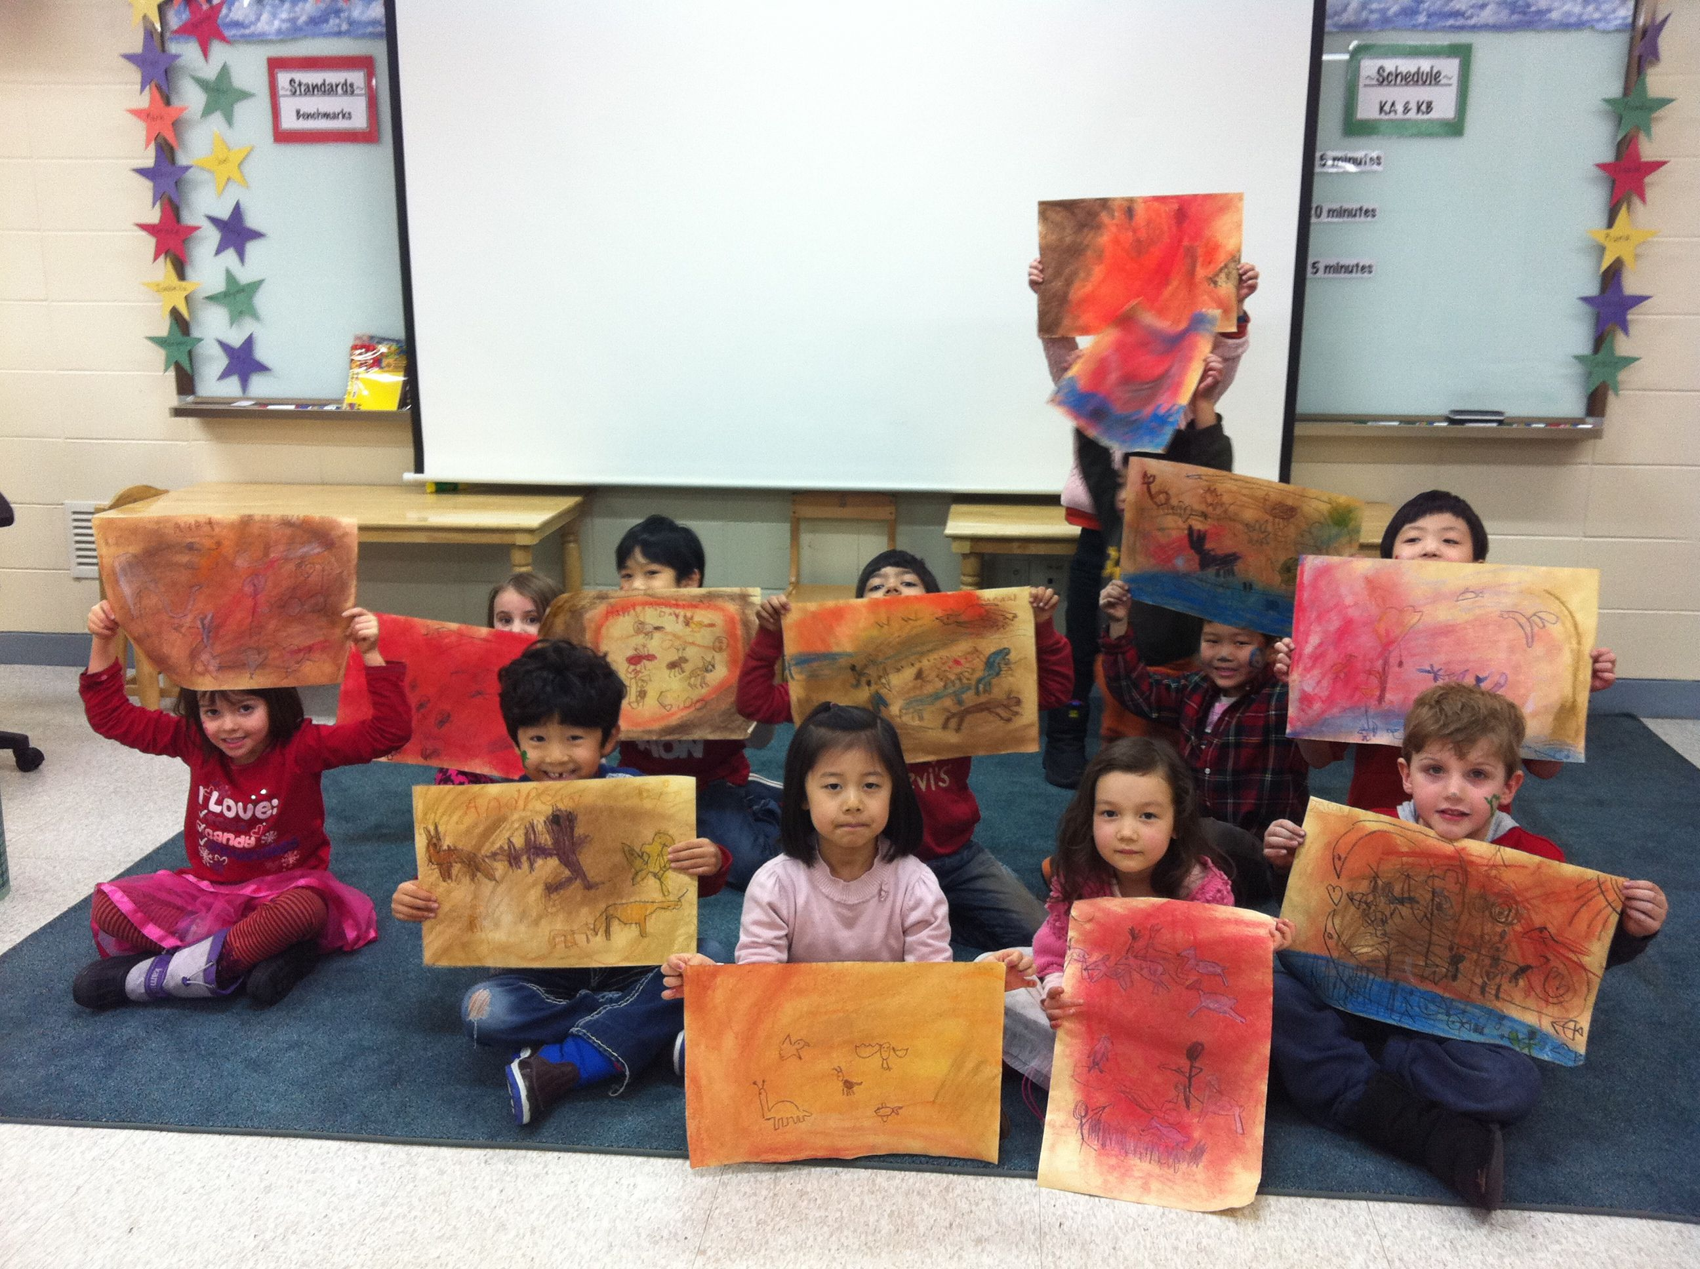

**The kindergarten classes have been working on cave paintings in art class!**

I hope you enjoyed your Lunar holiday break. It was a short, busy week! We had a great valentines day, filled with valentines, party games, book buddies and face painting! The kids really enjoyed the day. Thank you for supporting these activities by sending valentines and treats.

KIS elementary school will be celebrating READING WEEK from Feb.25-28. There will be an event or activity every day during this week. I will send a separate letter next week to explain the details. This will be a great way to get excited about reading!

Have a great weekend!

**Sight Words**

**please**

**how**

**would**

**know**

**Dates to Remember**

**Feb. 25-28:** Reading Week

**Feb 26th:** Author visit as KIS

**March 1st:** NO SCHOOL