



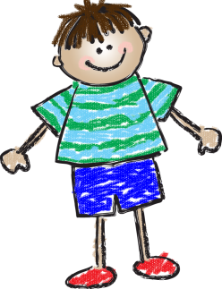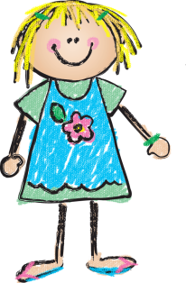

**with Ms. Rance**

**February 8, 2013**



**Weekly News…**



The kindergarten classes will be finishing a unit in P.E on dance next week. To celebrate all they have learned and to show off some of their new dance skills, each class will be having a “dance party” in the mini-auditorium. Mr. Duffy has arranged to have a disco ball, black lights and glow sticks for the students. To make it even more fun, Mr. Duffy has asked that students wear WHITE to school on this day so they can “glow” under the black lights. We will be having an extra P.E session for this celebration on FRIDAY, FEBRUARY 15th. Please have your child wear white to school on this day!

After school clubs start next week. If you have questions about clubs, please contact Amanda Willis ([awillis@kis.or.kr](mailto:awillis@kis.or.kr)). You should have received an email explaining what clubs your child is in for this quarter and what day/time they meet.

**Sight Words**

**kind**

**could**

**would**

**know**

**Reminders**

We will be having a valentine celebration and exchange on Thursday, Feb. 14th. Please send enough valentines for all students in kindergarten (24). Have you child sign their name and do not address valentines to students.

**Dates to Remember**  
**Feb 14th:** Kindergarten Valentine Party

**Feb 15th:** Wear white for P.E class

**Feb 26th:** Author visit as KIS

**A Look at Next Week…**

**The students have started a non-fiction book study on animals. Next week, they will use the information they have learned about their animal to create a digital story on the iPad. We are learning about time in math.**

**Quote of the Week**

**“Tell me and I forget. Teach me and I remember. Involve me and I learn.”**

**-Ben Franklin**